**Errors occurred during the project and solution**

1. Action : execute “tox -e train”

“config.yml” not found in the path when “tox -e train” is executed

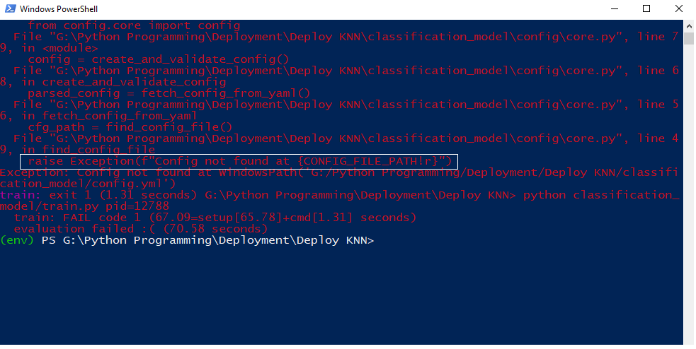

Solution :

The file should be named “config.yml” and not “config.yaml” you have to correct it

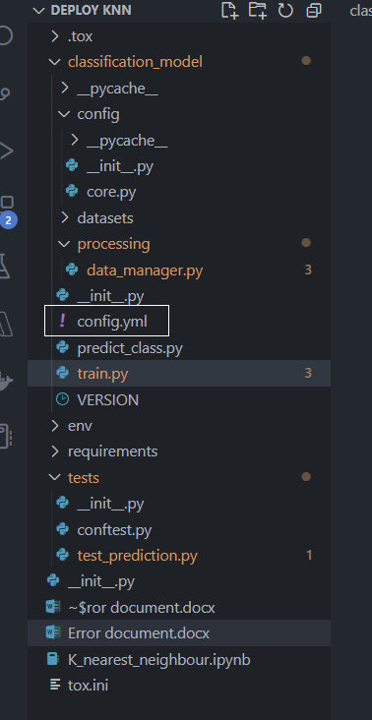

1. Action: execute “tox -e train” in powershell

Error : pydantic.error_wrappers.ValidationError: 1 validation error for AppConfig

test_data_file

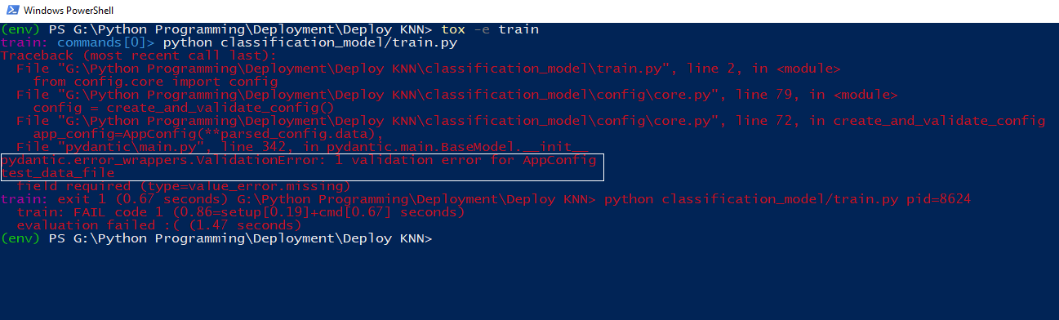

Solution : In the folder classification_model change the config.yml file.

test_data_file missing in config.yml file.

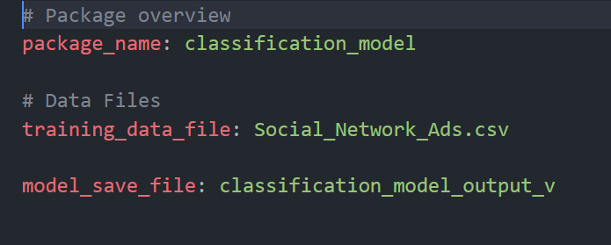

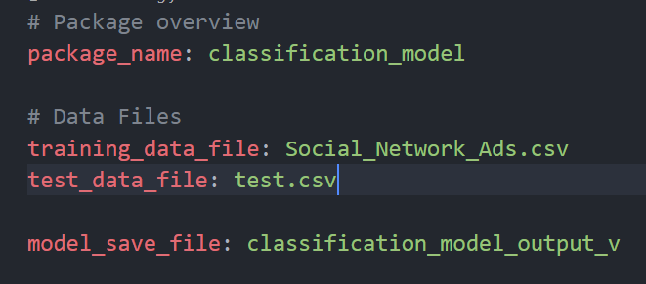

1. Action : execute “tox -e train” in powershell

Error : pydantic.error_wrappers.ValidationError: 3 validation errors for ModelConfig

target

value is not a valid integer (type=type_error.integer)

features -> 0

value is not a valid integer (type=type_error.integer)

features -> 1

value is not a valid integer (type=type_error.integer)

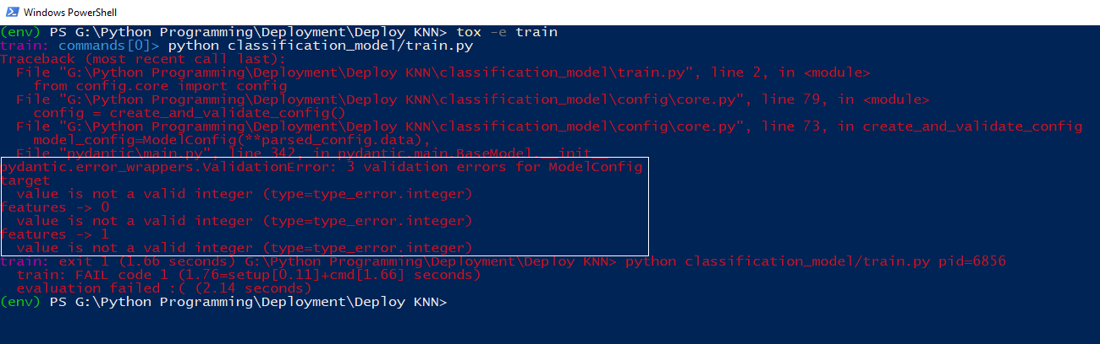

Solution : In the folder classification_model/config change the file core.py

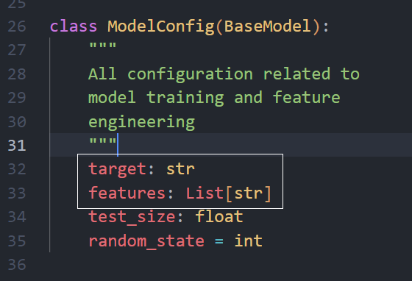

1. Action : execute “tox -e train”

Error : version file is not importing

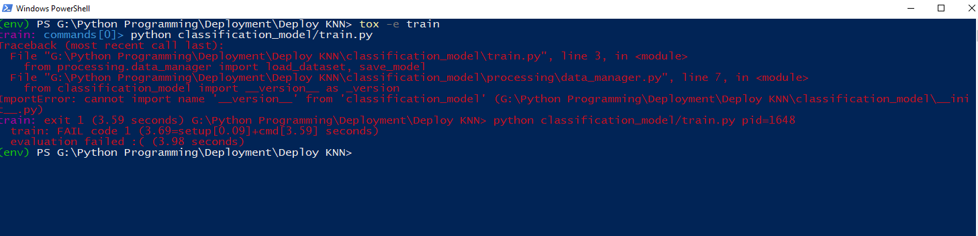

Solution :

In folder classification_model/processing/data_manager.py change the line. For the time being the code is commented.

1. Action: “tox -e train”

Error : Sklearn module not found

Solution :

Step 1:

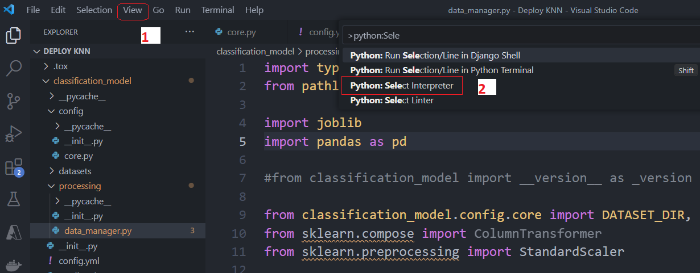

Step 2 :

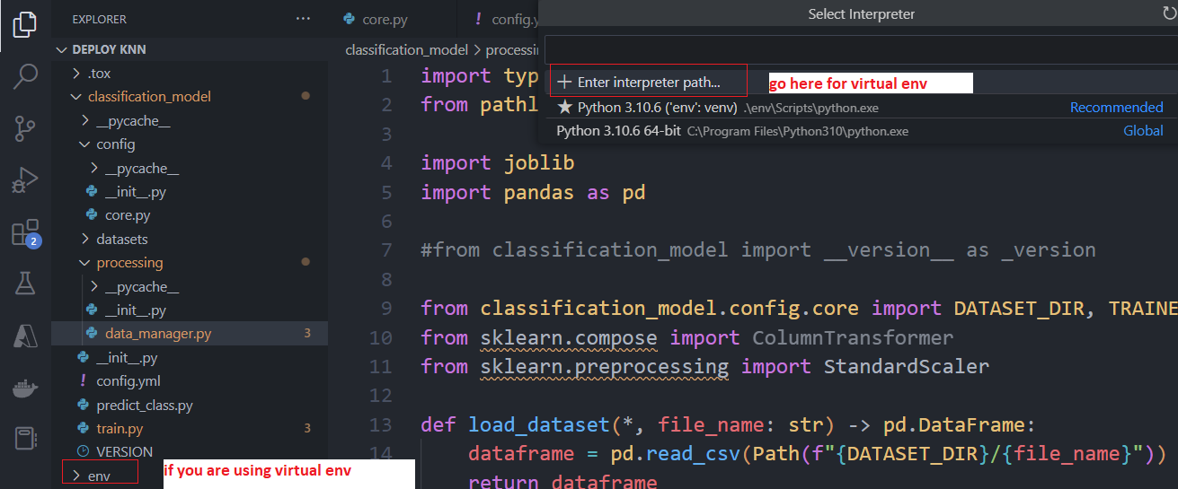

Below path will open

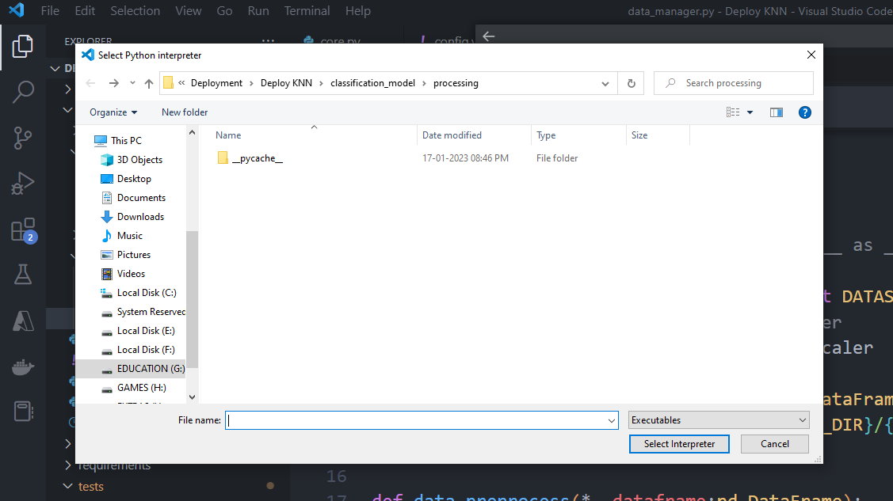

Step 3: Go to the virtual environment folder of your project.

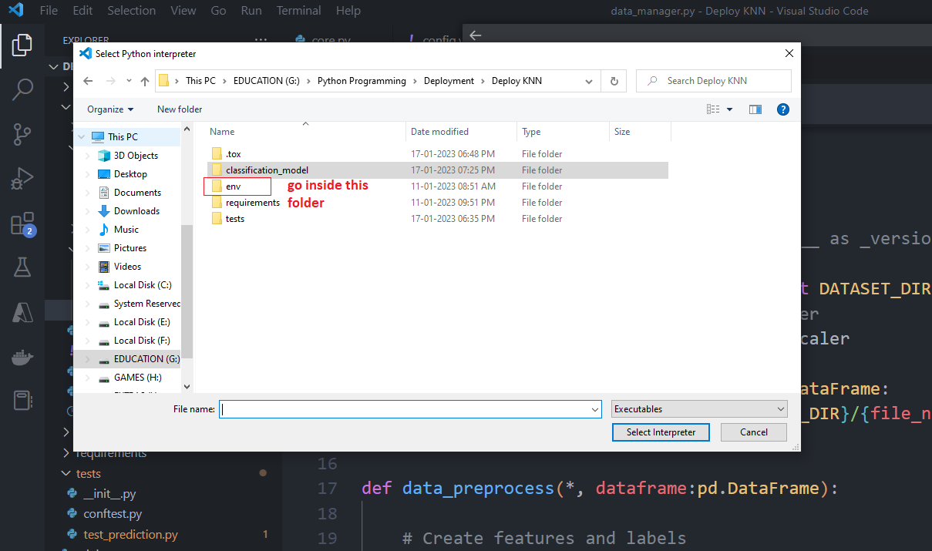

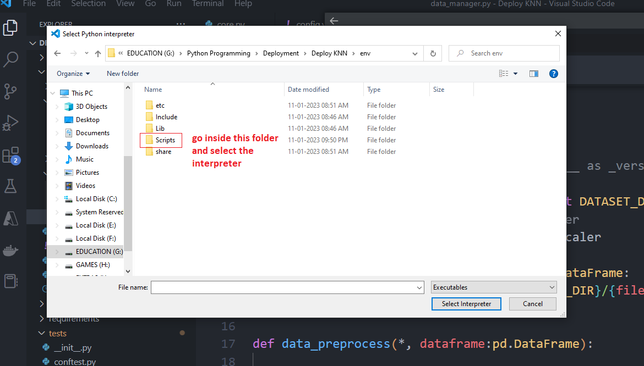

Step 4 : Slect the python interpreter and done…

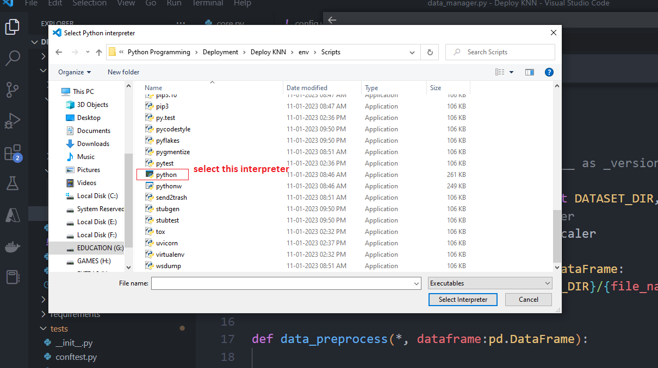

Important solution : pip install scikit-learn NOT sklearn

1. Action : “tox -e train”

Error : OSError: [Errno 22] Invalid argument

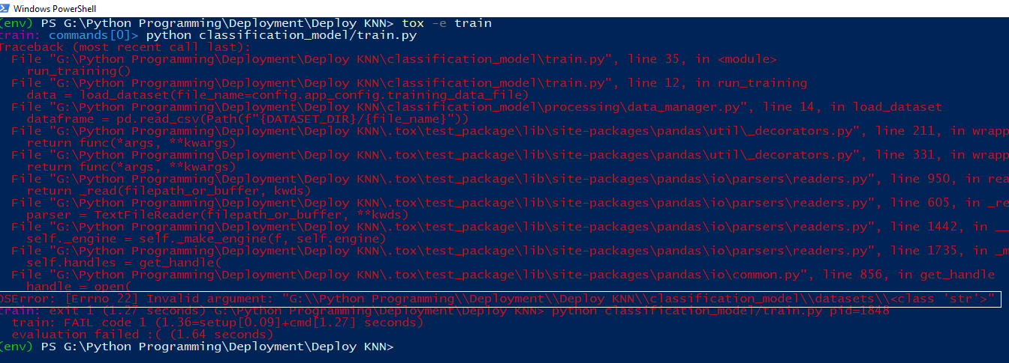

Solution :

Make change in folder “classification_model/config/core.py”

Make sure there is no error like below

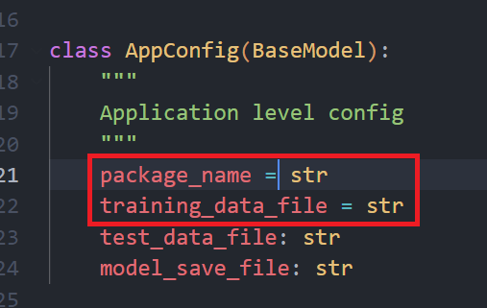

Change the “=” sign to “:” sign.

1. Action : Execute “tox -e train”

Error : FileNotFoundError: [Errno 2] No such file or directory:

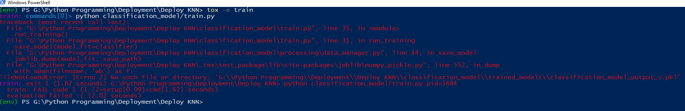

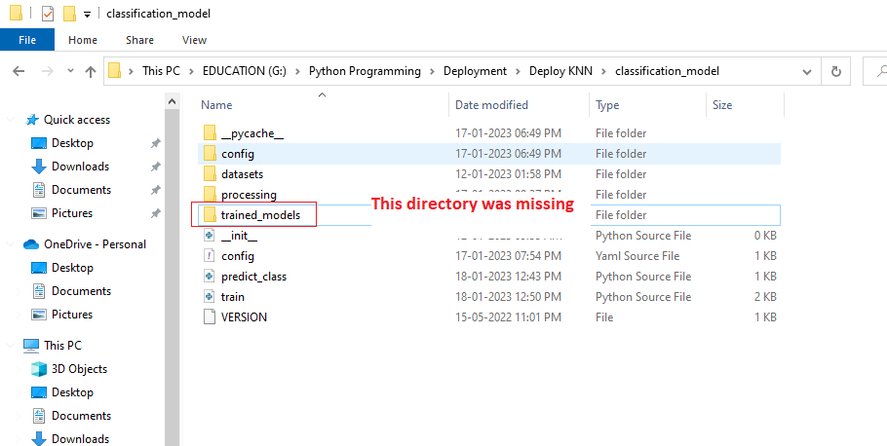

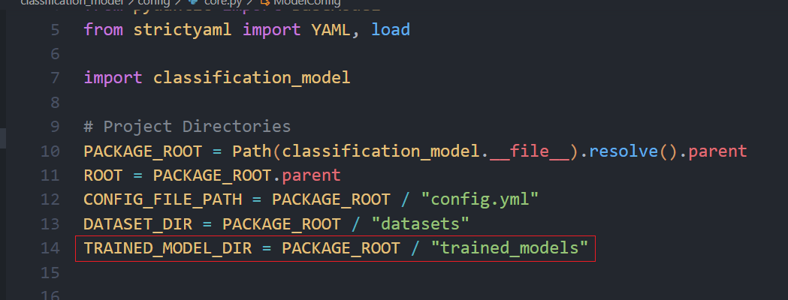

This directory was mentioned in the file path : classification_model/config/core.py

1. Action : “tox -e run_api”

Error : ERROR: Error loading ASGI app. Could not import module "api".

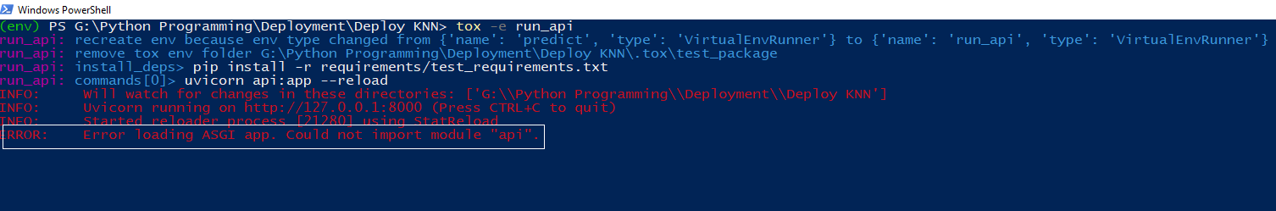

Solution :

Bring the “api.py” file to the main folder

Change the tox environment file